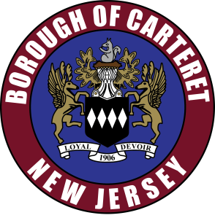
Borough of Carteret
61 Cooke Avenue
Carteret, New Jersey 07008

Zoning Board of Adjustment 2023 Schedule
Please take notice that the following Borough of Carteret’s Board of Adjustment meetings will be held via video and phone conference at 6:00 p.m.

Zoning Board of Adjustment 2023 Schedule
Tuesday, February 21, 2023
Tuesday, March 21, 2023
Tuesday, April 18, 2023
Tuesday, May 16, 2023
Tuesday, June 20, 2023
Tuesday, July 18, 2023
Tuesday, August 22, 2023
Tuesday, September 12, 2023
Tuesday, October 17, 2023
Tuesday, December 5, 2023
Tuesday, January 16, 2024

